SMALLEST OF TWO NUMBERS:

AIM: THE PROGRAM IS EXECUTED USING 8085 PROCESSOR SMALLEST OF TWO NUMBERS

ALGORITHM

* Input the first number.
* Input the second number.
* Check, Is the first number is smaller than the second number or not.
* If yes, print the first number.
* If no, Print the second number

INPUT:

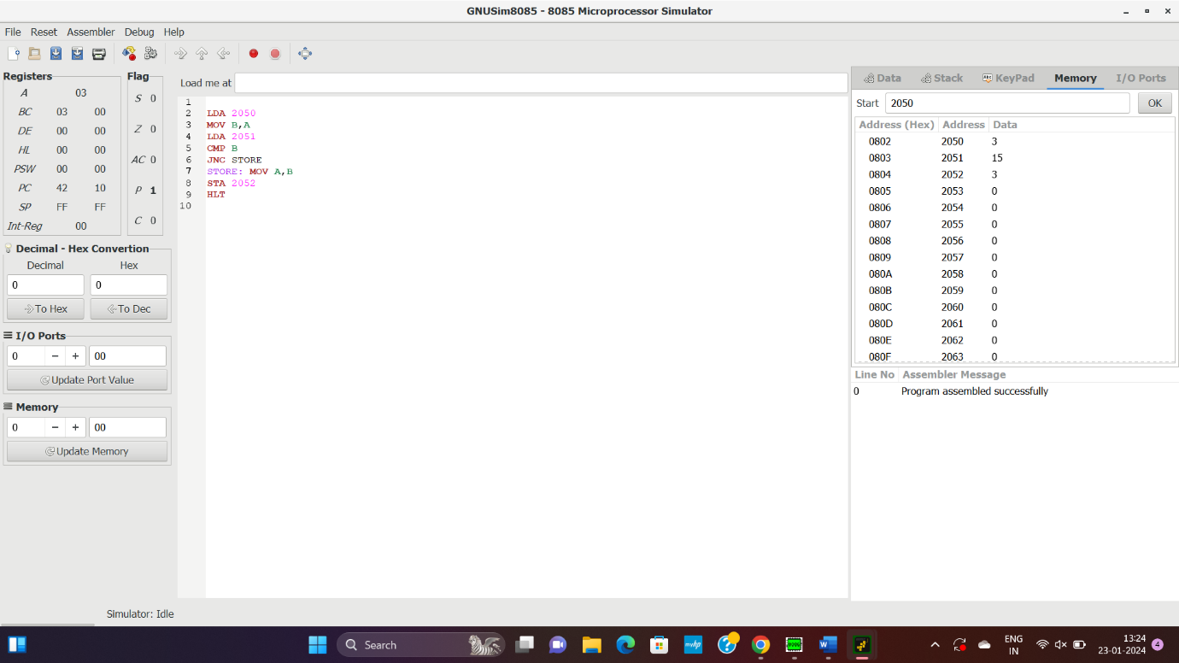

OUTPUT:

RESULT: THUS THE PROGRAM WAS EXECUTED SUCESSFULLY USING 8085 PROCESSOR.